DEFENSIVE AND  COMPETITIVE BIDDING | LEADS AND SIGNALS |  |  |  |  |  |  |  |  | 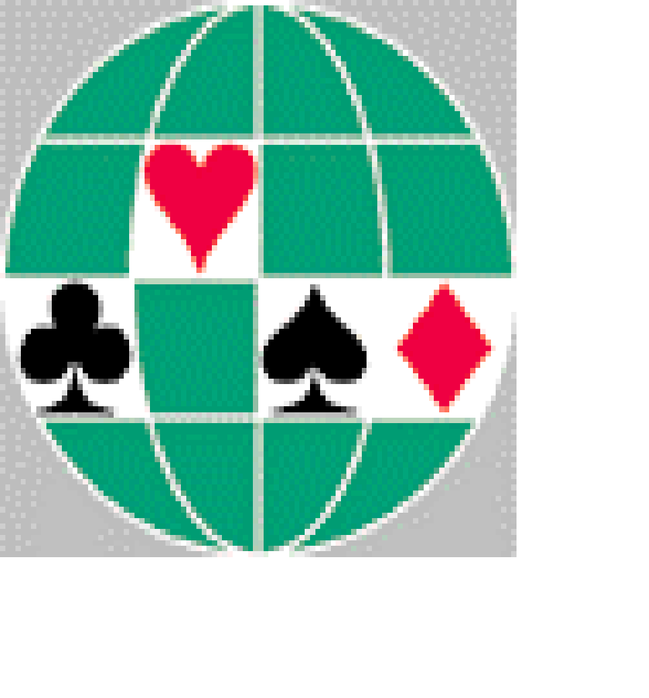
OVERCALLS (Style; Responses; 1/2 Level; Reopening) | OPENING LEADS STYLE |  |  |  |  |  |  | WBF and SBF  Convention Card
Aggressive at 1-level, 4+suit common |  |  | Lead |  |  | In Partner’s Suit
Responses: new suit F1 | Suit |  | 3/5 |  |  | 3/5
TRF after (1m) – 1M, starts with 2♦ showing 5+♥  2♣ =art 10+ w/o M-support (typically 5+m or NT invite+) | NT |  | Attitude |  |  | 3/5 or Attitude |  | Category: | Green
 | Subsequent |  | 1/3/5 (always in p suit) |  |  |  |  | NCBO: | Sweden
Jump cue = about 7-9 4+ supp |  |  | 2/4 through declarer in untouched suits |  |  |  |  | Event: | All
Sound on 2-level 5+suit | Other : |  | K asks for count against 5-level and higher |  |  |  |  | Players: | Mikael Rimstedt – Ola Rimstedt
1NT OVERCALL (2nd/4th Live; Responses; Reopening) | LEADS |  |  |  |  |  |  | SYSTEM SUMMARY
15-18 sys on | Lead | Vs. Suit |  |  | Vs. NT |  |  | GENERAL APPROACH AND STYLE
4th live 15-18 sys on | Ace | AKQ+ AKx+ Ax |  |  | AKx+ Ax |  |  | Generally sound openings, preempts may be (very) light
Reopen: 11-14 sys on or 11-16 sys off | King | KQJ+ KQT+ KQ+ AK |  |  | KQ+ Kx AKQx+ |  |  | 1♣ = 12-14 bal or nat
JUMP OVERCALLS (Style;Responses;Unusual NT) | Queen | QJT+ QJ9+ QJ+ |  |  | KQJx+ QJ+ Qx KQT9+ |  |  | 1♦ = 11+ 4+♦ always unbal / semi-bal (can be bal 3rd/4th seat)
Weak 5+ suit (Exceptions: (1♣ neb) – 2♦ = 5/5M  (1♦ neb) – 2♥ = 5/5M NF, (1M) – 3♣ = 5/5 oM+♦) | Jack | JT9+ JT+ |  |  | JT+ Jx |  |  | 1M = 11+ 5+M
 | 10 | HJT Tx |  |  | HJT+ T9x |  |  | 1NT = 15-17
2NT = 5-5 2 lowest unbid | 9 | HH9+ KJ9+ 9x |  |  | HH9+ or discouraging |  |  | 2♣ = FG or weak 5+♦ 3-10
Reopen: 2M 6+M 10-13; 2NT 19-21 bal sys on | Hi-x | Xx xxXxxx |  |  | Xx XXx XXxx H9XX HxxXX |  |  | 2♦ = 18-19 bal
DIRECT AND JUMP CUE BIDS (Style; Responses) | Lo-x | xxX xxXx xxxxX |  |  | Hxx H9xx HHxx H9xxx |  |  | 2M = Weak 5+M 5-10
(1M) – 2M = 5-5 oM+♣ | SIGNALS IN ORDER OF PRIORITY |  |  |  |  |  |  | 2NT = 20-21
(1m) – 2m = 5-5 M´s |  |  | Partner’s Lead | Declarer’s Lead |  |  | Discarding | SPECIAL BIDS THAT MAY REQUIRE DEFENCE
(2M) – 3M = ♣+♦ | Suit: 1st |  | Low = enc | Low = even |  |  | Low = enc | 1♣ opening = 2+
(1m neb) – 2m = nat | 2nd |  | Low = even | Suit-pref |  |  | Low = even | 2♣ opening = May be weak w/ diamonds
VS. NT (vs. Strong/Weak; Reopening; Passed Hand) | 3rd |  | Suit-pref |  |  |  | Suit-pref | 2♦ opening = 18-19 bal
Dbl = strength; 2♣ = MM; 2♦= a) weak M b) strong M+m;  2M = Nat (better than 2♦) 2NT = both m´ s | NT: 1st |  | Low = enc | Low = even |  |  | Low = enc | 1♣ - 2♦ = 6+M 9-11
 | 2nd |  | Low = even | Suit-pref |  |  | Low = even | 1♣ - 2♥ = 5+♥ 4♠ 3-9
By PH or 4th: dbl=MM or one m; 2m = m+higher; 2M = nat | 3rd |  | Suit-pref |  |  |  | Suit-pref | 1♦ - 2♥ = 5+♠ 4♥ 3-9
VS. PREEMPTS (Doubles; Cue-bids; Jumps; NT-bids) | Other signals: Trump Suit-preference; suit-pref sometimes top-prioritized;  3-way signal* when a) singleton / void in dummy / declarer b) shown 5+suit  * = Low or high card = suit-preference; Middle card = encouraging or neutral |  |  |  |  |  |  | SPECIAL FORCING PASS SEQUENCES
Dbl = T/O; (2/3M) – 4m = 5-5 m+oM |  |  |  |  |  |  |  | In game force situations
(3m) – 4♣ = 5-5 om+M; 4♦ = 5-5 M |  |  |  |  |  |  |  | After we rdbl for strength
2♦ multi: dbl =13-15 bal/17+; 2NT–16-19; 4m = 5-5 m+♥ | DOUBLES |  |  |  |  |  |  | IMPORTANT NOTES THAT DON’T FIT ELSEWHERE
VS. ARTIFICIAL STRONG OPENINGS | TAKE-OUT DOUBLES (Style; Responses; Reopening ) |  |  |  |  |  |  | Psychics: Occasionally
Vs strong 1♣: dbl = good hand; 1X = Nat  1NT = ♠+♦ or ♥+♣; 2X = X or next two suits | May be light with good distribution |  |  |  |  |  |  | Not strict about hcp ranges
 | Dbl is almost always take-out |  |  |  |  |  |  | 3rd hand openings may be light
Vs strong 2♣/♦: dbl = MM; 2X = nat; 2NT = any two-suits | SPECIAL, ARTIFICIAL AND COMPETITIVE DOUBLES/REDOUBLES |  |  |  |  |  |  | Often transfers in competition (See examples below);
OVER OPPONENTS’ TAKE-OUT DOUBLE | Support r/dbls on the 1-level |  |  |  |  |  |  | 1♣ (dbl/1♦) 1♦/dbl = 4+♥, 1♥ = 4+♠; 1m (1♥) dbl = 4+♠
TRF after 1M – (dbl) starts with 1NT showing 5+suit | Invitational doubles when no other bid available |  |  |  |  |  |  | 1♣ (1♠) 2♣/♦/♥ = 5+♦/♥/♣; 1♦ (1♠) 2♣ = 5+♥; 2♥ = 5+♣
Rdbl = strength | Non-lead directing dbls when a) bid the suit naturally b) supported the suit |  |  |  |  |  |  | 1♥ (1♠) 2♣ = 5+♦; 2♦ = good ♥ raise; 2♠ = 5+♣

OPENING BID DESCRIPTIONS Mikael Rimstedt & Ola Rimstedt – Sweden
Open ing | Tick if  Art | Min  No  Cards | Neg Dbl Thru | Description | Responses | Subsequent Auction
1♣ | X | 2 | 4♠ | a) 12-14 bal (includes 5♦2♣)  b) 11-23 nat | 1♦ = (3)4+♦, NOT 4♥/♠ (may have 3334); 1M = 4+M F1  1NT = Nat 11-13; 2♣ = 5+♣ 5-11; 2♦ = 6+M 8-11  2♥ = 5+♥ 4♠ 3-9; 2♠ = 6+♣ FG; 2NT = both m´s 0-10  3♣ = 6+♣ INV; 3♦/♥ = 6+♥/♠ a) preemptive b) FG solid suit;  3♠ = TRF to 3NT; 4m = good 4M bid, 4M = bad 4M bid | 1♣-1♦: 1M nat unbal; 1NT = 12-14 bal; 2NT = 6+♣ 16+  1♣-1M: 1♠ = Nat unbal F1; 1NT = 12-14 bal; 2♣ = 5+♣ 11-15;  2♦ = Art 16+ not 3+M; 2oM = Art 16+ w/ 3+M;  2M = 3-4M; 2NT = 6+♣ 16-18; 3♣ = Solid suit 13-15
1♦ |  | 4 | 4♠ | a) 5+♦ 11-23 (not 5♦(332))  b) 4♦(441) 11-22  1st/2nd always unbal or semi-bal  3rd/4th may be balanced | 1M = 4+M F1; 1NT = FG bal or ♣ or ♦; 2♣ = 5+♣ 4-11;  2♦ = 3+♦ 0-9; 2♥ = 5+♠ 4♥ 3-9; 2♠ = 6+♣ 9-12;  2NT = Nat 11-13; 3♣ = 4+♦ 9-12; 3♦ = 4+♦ 0-8;  3M = void SPL; 4m = good 4M bid; 4M = bad 4M bid | 1♦-1♥: 1♠=4+♠ F1; 1NT=3♥ 11-13; 2♣ = 4+♣ 11-15 / 16+ any  2♦=6+♦not3♥; 2♥=good 3♥/bad 4♥; 2♠=Art 16+w/ 3+♥  2NT = 6+♦ 16+; 3♣ = 5/5 14-16; 3♦ = Solid suit 13-15  1♦-1♠: 1NT = 6+♦ or 4♥ 11-15; 2♣ = 4+♣ 11-15 / 16+ any  2♦=3♠ 11-13; 2♥=Art 16+ w/ 3+♠; 2♠=good 3♠/bad 4♠  2NT = 6+♦ 16+; 3♣ = 5/5 14-16; 3♦ = Solid suit 13-15  1♦-1NT: Artifical responses
1♥ |  | 5 | 4♠ | 5+♥ 11-23 | 1♠ = 4+♠ F1; 1NT = Nat 4-11; 2♣ = FG bal or ♣ or ♥;  2♦ = FG 5+♦ unbal;2♥ = 8-11 3/4♥; 2♠ = FG 6+♠ or 5/5 ♠+m;  2NT=4+♥ INV+; 3m=Nat INV; 3♥=3-7; 3♠=any void 12-14 | 1M-1X: 2♣ = 4+♣ 11-14 or 15+ any; 2NT = 6+M 4m 15+;  3m = 5/5 14-16; 3♥ = 5/5 13-15; 3M=6+M mild invite  1M-2♣: Artifical responses
1♠ |  | 5 | 4♥ | Same as above | Same as above (2♥ = 5+♥ FG; 2♠ = 8-11 3/4♠) | Same as above
1NT |  |  | 4♠ | (14)15-17 bal | 2♣ = Stayman; 2♦/2♥/2♠/2NT = TRF; 3♣ = FG both m  3♦ = 6+M INV; 3M = 4M w/ SPL oM; 4♣/♦ = TRF to 4♥/♠ | 1NT-2♣: 2♦ = no 4M; 2M = 4+M; 2NT/3♣ = 4/4M min/max  1NT-2♠/2NT: 3♣/♦ = likes ♣/♦
2♣ | X | 0 |  | a) Weak (5)6+♦ (See 2M)  b) 22+ bal c) Any FG | 2♦ = P/C; 2M = Nat F1; 2NT = INV+ relay; 3♣ = Nat F1;  3♦ = P/C; 3M = good 6+M forcing | 2♣-2♦: 2♥ = 5+♥ or 25+ bal; 2♠ = 5+♠; 2NT = 22-24 bal  3♣ = 5+♣ 4X; 3♦ = 5+♦ 4+♣ or 6+♦; 3M = 5+♦ 4M
2♦ | X | 2 | 4♠ | 18-19 bal | 2♥ = ♠ or one-suiter S/T; 2♠ = ♥ or NT or 6+m short om;  2NT = ♣ or ♥ or bal S/T w/o M; 3♣ = Stayman; 3♦ = 5+♠ 4♥; 3M = short M w/ both m or one m; 3NT = 5-5M forcing; | 2♦-2♥: 2♠ = 2-3♠; 2NT = 4♠  2♦-3♣: 3♦ = one or both M; 3♥ = 3♥ not 4♠; 3NT = not 3♥ / 4♠  2♦-3NT: 4♣ = sets ♥; 4♦ = sets ♠; 4♥ = 2-2M
2♥ |  | 5 |  | White: 5+♥ 5-10  Red: 6+♥ 5-10 | 2♠ = 5+♠ F1; 2NT = INV+ asking; 3♣ = 5+♦ or to play 3♠;  3♦ = 5+♣; 3♥ = PRE | 2M-2NT (Non-vul): 3♣ = min with 5M; 3♦ = max with 5M  3♥ = min with 6M; 3♠ = max with 6M  2M-2NT (Vul): 3♣ = max; 3♦ = min with bad suit  3M = min with good suit; 3oM = 4♣/♦ max
2♠ |  | 5 |  | White: 5+♠ 5-10  Red: 6+♠ 5-10 | 2NT = INV+ asking; 3♣ = 5+♦ or to play 3♥; 3♦ = 5+♥ INV+  3♥ = 5+♣; 3♠ = PRE
2NT |  |  | 4♠ | 20-21 bal | 3♣ = Puppet; 3♦/3♥ =TRF; 3♠ = both m’s 4♣/4♦ = S/T 6+♥/♠ | 2NT-3♣: 3♦=one or both M; 3♥=no M; 3♠ = 5+♠; 3NT = 5+♥
3X |  | (5)6 |  | Preemptive, very light NV vs V | 3♣-3♦ = pupp to 3♥; 3♦-3♥ = pupp to 3♠; 3M-4♦ = pick-a-M
3NT | X |  |  | 1st/2nd Solid M, no outside A/K | 4♣ = ask short; 4♦ = ask length; 4M = P/C | HIGH LEVEL BIDDING
4♣ |  | 6 |  | Preemptive | 4♦ = pick-a-major or S/T in ♣; 4M = to play; 4NT = to play | 1430 (5NT = odd + void, 6X = even + void)
4♦ |  | 6 |  | Preemptive | 4M = to play; 4NT = to play; 5♣ = S/T in ♦ | Non-srs 3♠/3NT/4m, last train, voidwood 0314, DOPI, DEPO
4♥ |  | 6 |  | Preemptive | 4♠ = to play; 4NT = RKC | Cue bids up the line 1st or 2nd
4♠ |  | 6 |  | Preemptive | 4NT = RKC | If not RKC 1430, 4NT 2-places to play and 5NT pick a slam
4NT | X |  |  | Specific ace asking | 5♣ = no Ace; 5♦/♥/♠ = that Ace; 5NT=♣ Ace; 6X = 2 Aces | When FP pass and pull is S/T

